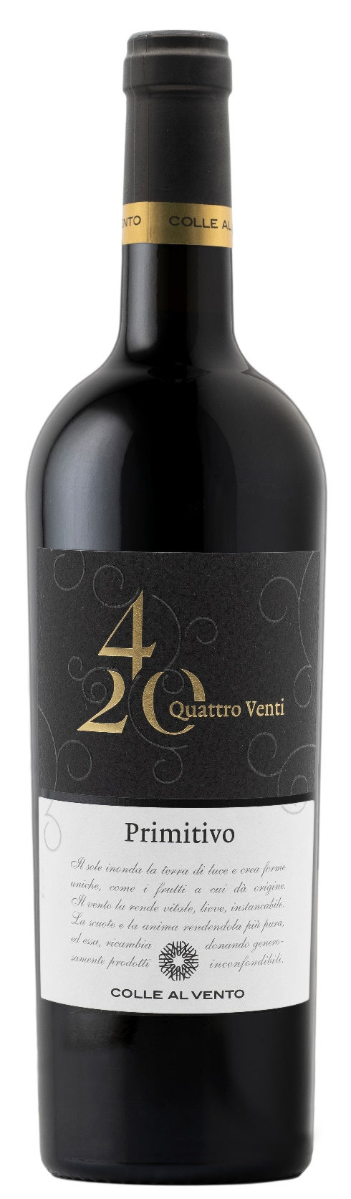
PRIMITIVO SALENTO IGP – 4/20

Grape: Primitivo 100%
Alc. Vol.%: 14
Vintage: 2025
Residual sugar g/l: 8,0
Total acidity g/l: 6,1
Region: Apulia
Production zone: Vineyards in the Salento area
Capacity: 750ml

CHARACTERISTICS

Vinification: After the exertion of soft pressure and the separation of grape-stalk, traditional short maceration and fermentation at a controlled temperature. To better extract colour and tannins, it is pumped over several times
Aging: Aged in steel tanks until bottling
Yield per ha: 12000kg
Colour: Intense bright red
Bouquet: Aromas of red mature berries and flowers
Flavour: Dry, strong and velvety

SERVING SUGGESTIONS

Excellent with all meat dishes.
Serving temperature 18 °C
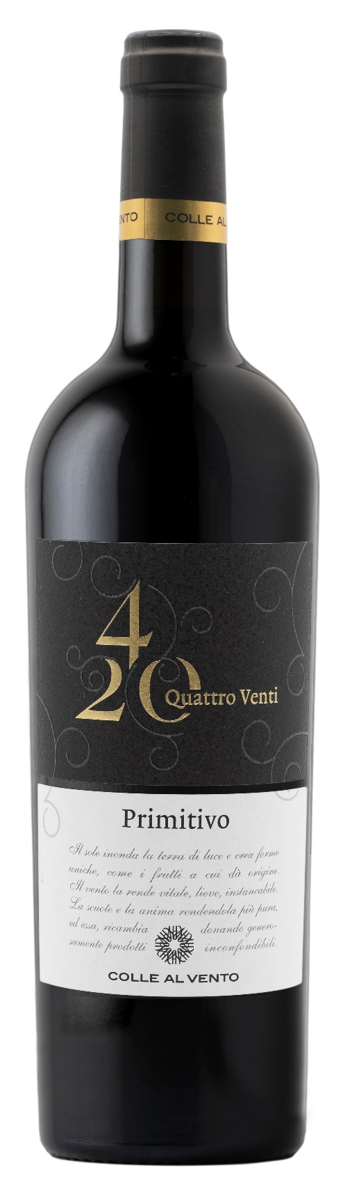
TECHNICAL INFORMATION / PALLETIZING

Size 750ml:
Article Nr. V03011A
GTIN-13 bottle 8017868001638
GTIN-13 carton 8017868002031
Closure Cork
Bottles / carton 6 bottles
Pallet size 80x120cm
Cartons/layer 21
Cartons/pallet 105
Kg/carton 8,1
Kg/pallet 870

Contains sulphites
GMO Free
Revisione 01. 14.05.2026

